Incident Reporting Form
When you submit this form, it will not automatically collect your details like name and email address unless you provide it yourself.
Required *
1.Type of Incident / Accident *
- Medical
- Theft
- Fire
- HR Related Incident
- Outside Work Place Violence
- Threat
- Death
- Fraud
- Any Other Safety / Security Related Incident
- Other –
Enter your answer
2.Date of Report *
3.Time of Report (HH:MM) *
4.Name of Impacted Employee / Person *
5.Employee ID of Impacted Employee *
6.Was this incident reported verbally before submitting this report? *
** In case of medical emergency inform local HR
- Yes
- No

If Yes then
7.Incident reported to: *
- Supervisor
- Manager
- HR
- Other Employee
- Not Reported
8.If Yes, to whom ( Name and Department ): *
9.Location of Incident or Accident (Specify Office / Branch) *
10.Reported By - Name & Employee ID: *
11.Reported By - Employee email address *
12.Reported By - Contact Number *
13.Date of Incident Occurred *
14.Time of Incident *
15.Detailed Description of Incident (long ans) *
16.Immediate Actions Taken: (long ans) *
17.Accompanying Person Name and Contact Details *
18.Name of Witnesses or Employee present during the incident/accident: *
19.Contact Number - Witness or Employee *
20.Root cause analysis of the incident/accident:
21.Preventive actions taken during or after incident/accident (If any):
Attach File uploads (images/pdf)
Submit

If No then
7.Location of Incident or Accident (Specify Office / Branch) *
8.Reported By - Name & Employee ID: *
9. Reported By - Employee email address *
10.Reported By - Contact Number *
11.Date of Incident Occurred *
12.Time of Incident *
13.Detailed Description of Incident (long ans) *
14.Immediate Actions Taken: (long ans) *
15.Accompanying Person Name and Contact Details *
16.Name of Witnesses or Employee present during the incident/accident: *
17.Contact Number - Witness or Employee *
18.Root cause analysis of the incident/accident:
19.Preventive actions taken during or after incident/accident (If any):
Attach File uploads (images/pdf)
Submit

Print (IN pdf)

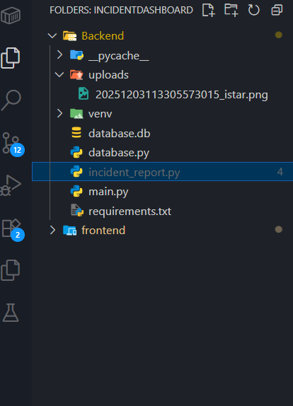
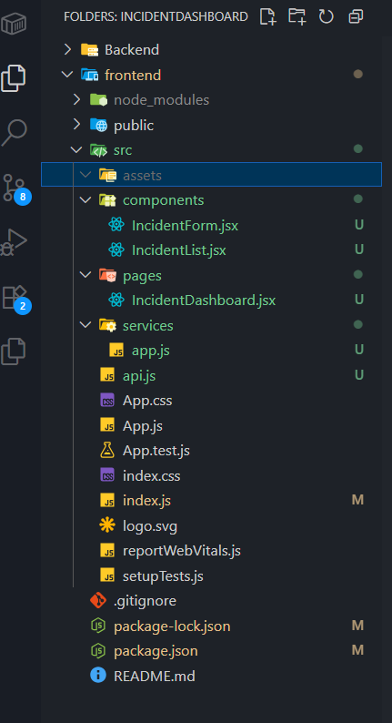
Western Union
Incident Reporting & Management System
Project Documentation (Frontend + Backend)

1. Project Overview
The Incident Reporting & Management System is a web application designed for Western Union employees, managers, HR, and security teams to report and manage workplace incidents.
The system allows any employee to submit incident reports online, and authorized teams can review, analyze, and take actions based on the information collected.

This platform improves:
✔ Safety
✔ Compliance
✔ Transparency
✔ Response speed
✔ Data accuracy

2. Project Goals
Primary Objectives

1. Provide a simple digital form for reporting incidents.
2. Store all incident data in a secure backend system.
3. Allow HR & Security teams to view, search, and analyze incident patterns.
4. Maintain accurate records for audits, compliance, and investigations.
5. Improve workplace safety and incident response time.

3. System Features

✔ Frontend Features (Employee-facing)
1. Incident Form
Employees can submit:
Type of incident (Medical, Theft, Fire, HR issue, Violence, Death, Fraud, etc.)
Date and time of report
Name & employee ID of impacted person
Was it verbally reported earlier?
If yes → whom it was reported to
Location of incident
Reporter details
Witnesses
Accompanying persons
Detailed incident description
Root cause (optional)
Preventive actions (optional)
File uploads (images/videos)

2. Auto-Save Feature
The form automatically saves draft data in browser localStorage.
If browser closes unexpectedly → data is not lost.

3. Incident List (Admin/Security/HR)

View all reported incidents
Search incidents by:
Type
Impacted person
Reported by
Location

Table format
"View" button shows complete incident details
Modal popup to see incident JSON data
Export to Excel / PDF

4. Simple, responsive UI
Clean, professional layout
Suitable for desktop & laptop usage
Separate dashboard and form area

4. Backend Features (API + Database)

✔ Backend (FastAPI / Python)

1. Create Incident API
POST /incident/create
Accepts full incident report
Validates required fields
Saves record to database
Returns success response

2. Get All Incidents API
GET /incident/list
Returns list of all incidents
Used by IncidentList component

3. Backend Validations

Ensures:
Required fields are provided
Data types are correct
Large text fields are allowed
Arrays (witnesses, accompanying people) are accepted

4. Database Storage
Stores incident reports in a structured format
Supports future analytics

6. User Types

1. Normal Employee
Can fill the incident reporting form
Can submit incident once
Cannot view all incidents

2. HR / Security / Admin

Can view all incidents
Can search incidents
Can download or analyze data
Can use dashboard for future planning

7. Workflow

Step 1 → Employee opens Incident Form
Step 2 → Fills details (auto-save works)
Step 3 → Submits the report
Step 4 → Backend validates and stores in DB
Step 5 → HR/Security team sees the report in Incident List
Step 6 → Data used for:

Workplace improvements
Risk management
Compliance
Safety tracking
Investigations

8. Future Scope (Phase 2 & Phase 3)

This project can be expanded easily.
Here are recommended future enhancements:
✔ Login system (Employee / HR / Admin roles)
✔ Email notification to HR/security
✔ Graphs and analytics dashboard
✔ Incident severity rating

